**Brief Medical History Form**

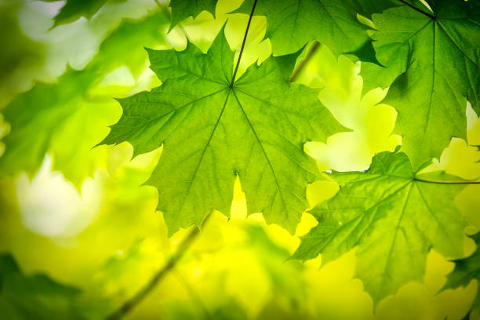

**Insert your**

**logo here**

(Pages 1–2 completed by client before or at time of service, page 3 completed by therapist)

**Date:** _______________

**Name:** _____________________________________________ **DOB:** __________________________

**What is the reason why you are seeking help?** ____________________________________________

____________________________________________________________________________________

**Have you received manual lymphatic drainage before?  Yes  No**

If yes, by whom: ______________________________________________________________________

**What are your current symptoms/complaints?** ___________________________________________

____________________________________________________________________________________

**Have you had other therapies for the same symptoms/complaints?  Yes  No**

If yes, please explain your experience, success, or lack of success:

____________________________________________________________________________________

**What are your treatment goals?** ________________________________________________________

____________________________________________________________________________________

**Have you had any surgery?  Yes  No**

If yes, list surgeries and dates: ___________________________________________________________

____________________________________________________________________________________

____________________________________________________________________________________

**Have you had any cancer surgery?  Yes  No**

If yes, where and when: ________________________________________________________________

____________________________________________________________________________________

**Have you had any lymph nodes removed?  Yes  No**

If yes, how many: _____________________________________________________________________

**Have you ever received radiation therapy for cancer?  Yes  No**

If yes, list area of radiation and dates here: _________________________________________________

____________________________________________________________________________________

**Have you had chemotherapy?  Yes  No**

If yes, how long ago?___________________________________________________________________

**Have you had any infections (cellulitis)?  Yes  No**

If yes, please explain: _________________________________________________________________

**Do you have pain?  Yes  No**

If yes, please explain: __________________________________________________________________

___________________________________________________________________________________

**Do you have any loss of function or mobility?  Yes  No**

If yes, please explain: __________________________________________________________________

____________________________________________________________________________________

**Do you currently suffer from (or have you had) any of the following?**

|  |  |  |
| --- | --- | --- |
|  Asthma |  Hyperthyroidism |  Crohn’s Disease |
|  Bronchitis |  Kidney failure |  Diverticulitis |
|  Difficulties breathing |  Diabetes |  Recent abdominal surgery |
|  Irregular heart beat |  Infections (cellulitis) |  Unexplained pain |
|  Heart edema |  Sleep apnea |  Deep venous thrombosis (blood clot) |
|  Hypertension |  Malignancy (cancer) |  Latex allergy |
|  Swelling (edema) |  |  |

**Do you have any allergies?** If yes, please explain: ___________________________________________________________________________________

**Do you have any other medical problems not listed above?  Yes  No**

If yes, please explain: _________________________________________________________________

**Are you taking any medication?  Yes  No**

If yes, list medications and amounts here: _________________________________________________

___________________________________________________________________________________

**At the time you are completing this, are you pregnant or is there a chance you could be pregnant?**

** Yes  No**

**Do you exercise regularly?  Yes  No**

If yes, please describe: _________________________________________________________________

____________________________________________________________________________________

**Is there anything else you would like to tell us at this time?** _________________________________

____________________________________________________________________________________

Treatment Plan (This page is to be completed by therapist):

**Reason for treatment: Contraindications/precautions:**

 General MLD to promote health  Neck treatment

and relaxation / general detoxification

 Abdominal Treatment

 Post-surgical, post-traumatic

 History of CHF, DVT, CKD

 Lymphedema (also complete

lymphedema addendum)  LN precautions ____________________

 Other_________________________  Other____________________________

**Indicate current findings and MLD sequence:**

**Key:**

Edema (swelling):

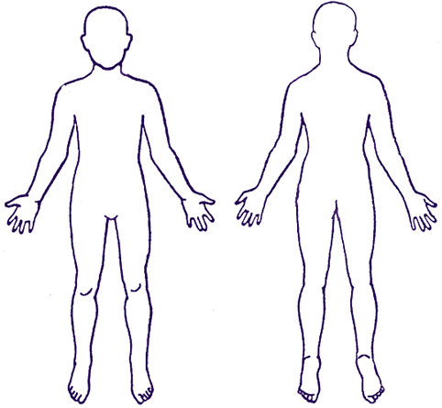Scar(s):   
Node removal: ♦  
Radiation field (if applicable:   
Tissue Tignes/fibrosis: ###  
Numbness/tingling: ***  
Pain: (0= no pain;   
10= worst pain)