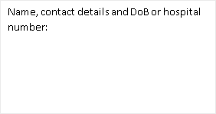
Lower Limb and Genital Lymphedema Questionnaire for Women
(LLGLQw)
Self-completion questionnaire for women who have lower limb edema and may have genital area oedema / Lymphedema.
Today’s date:
Swelling in the legs / genitals can be quite normal for a few weeks after some treatments or with some chronic conditions. Sometimes these can be difficult to describe but this questionnaire may help. Please complete the questions below to help us give you the appropriate advice and care.

Personal Impact  Over the last month how has the swelling affected your daily activities: |  |  | Not at all  (or not relevant) 0 | A little bit  1 | Quite a bit  2 | Very much  3
 |  | (for example) |  | ✓
I have swelling: |  | in my leg(s)
 |  | in my genitals
If you feel you have no swelling at all you do not need to complete the rest of this questionnaire.
The swelling is worse by the end of the day
The swelling is affecting: |  | which clothes/shoes I can wear
 |  | my sitting
 |  | getting in/out of bed
 |  | my walking
 |  | urination
 |  | my sexual function
The skin around the swollen area: |  | feels tight
 |  | has changed colour
 |  | feels different
 |  | feels wet/cold
The swelling gives me discomfort: |  | in my leg(s)
 |  | in my genitals
I need to take painkillers for the discomfort
Please continue overleaf/next page.
Therapist to calculate after completion | Score for Personal Impact Section (score above / 48) x 100= % limited

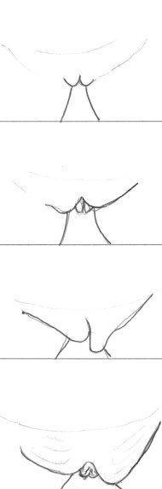
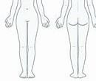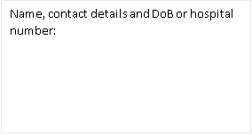

If you have swelling of your legs or genitals please show in these picture where you feel it is, by shading like this:

Please tick any relevant |  | √
 | I feel
 | swollen
 | inside
 | The inside
 | is sticking
 | out
 | The
 | outside is
 | swollen
 | Inside and
 | outside
 | feels
 | swollen

On average this week how severe has the swelling been?
 | 0 =No swelling | 1 = a little bit | 2 = quite a bit | 3 = very swollen
Legs
Genitals

Is there anything else you would like to tell us about how this is affecting you physically or emotionally?
 | Yes | No
During the last year, have you needed antibiotics for infections (cellulitis) in your leg(s) or genitals?
Have you been offered any advice or treatment for the things you have identified here?
Would you like to discuss this with us?
Health professional to complete:
Name of health professional has discussed the contents of this form with the patient Signed: Date:

