Lower Limb and Genital Lymphoedema Questionnaire for Men (LLGLQ)
Patient/client (name, address, contact details).
Self-completion questionnaire for men who have lower limb oedema and may also have genital area oedema / Lymphoedema.

Today’s date:

Swelling in the legs / genitals can be quite normal for a few weeks after some treatments or
with some chronic conditions. Sometimes these can be difficult to describe but this questionnaire may help. Please complete the questions below to help us give you the appropriate advice and care.

Changes in your lower body since your cancer treatment |  | Not at all  (or not relevant) 0 | A  little bit  1 | Quite a bit  2 | Very much  3
 | (for example) |  | ✓
I have swelling: | in my leg(s)
 | in my genitals
If you feel you have no swelling at all you do not need to complete the rest of this questionnaire.
The swelling is noticeably more by the end of the day
The swelling is affecting: | which clothes/shoes I can wear
 | my sitting
 | getting in/out of bed
 | my walking
 | urination
 | my sexual function
The skin around the swollen area: | feels tight
 | has changed colour
 | feels different
 | feels wet/cold
The swelling gives me discomfort: | in my leg(s)
 | in my genitals
I need to take painkillers for the discomfort
During the last year have you needed antibiotics for infections (cellulitis) in your leg(s) or genitals? |  |  |  | Yes | No
If yes, how many times has this happened?

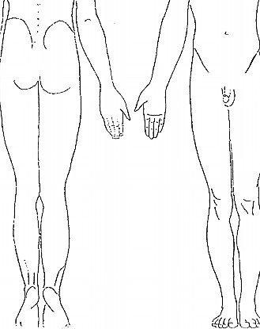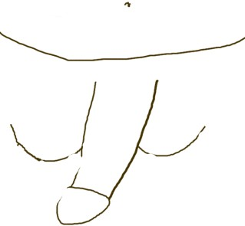
If you have swelling of your legs or genitals please show in this picture where it is,
by shading like this:
Patient/client (name, address, contact details).

On average this week how severe has the swelling been?
0 = No swelling | 1 = a little bit | 2 = quite a bit | 3 = very swollen

Is there anything else you would like to tell us about how this is affecting you physically or emotionally?
 | Yes | No
Have you been offered any advice or treatment for lymphoedema (swelling)?
Would you like any information or advice?
For completion by doctor/therapist/nurse:
Referred to Lymphoedema service for assessment? (date)

