Your Logo Here!

- Contact Information: Therapist Name & Phone Number

LYMPHEDEMA EVALUATION:
Referring Clinician:

Last: First: DOB: Age: Gender:
Assessment Date:
Medical Diagnosis: Treatment Diagnosis:
Type of Therapy:
Start Time: End Time: Total Time:
Charges: Time: Time:
Reason for referral: Intractable lymphedema of the , unrelieved by elevation.

Lymphedema History:
Chief Complaint:

▒ = lymphedema xxxx= fibrotic tissue ooo= pitting edema ///= pain
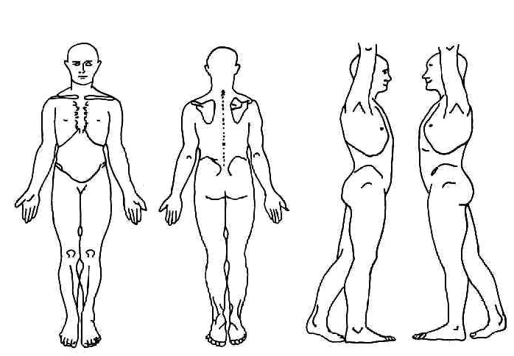
Onset: Triggering Event:
Past History:
Surgery:
Radiation Therapy:
Chemotherapy:
Lymph node removal:
History of Cellulitis/Infection:
Family history of lymphedema:
Previous treatment for lymphedema:
Current compression garment use:

Medical History:
Medications:
Allergies:
Pain: Location: Description:

Objective observations:( ROM, MMT, Skin Integrity, etc.)
Measurements: see limb volume calculations-attached

Prior Level of Function:
Living Situation:
Self Care:
Grooming: Bathing: Dressing: Other:
Gait:
Functional Limitations:
Precautions:
Rehab Potential: This patient demonstrates the ability to follow the plan of care and progress towards goals. Rehab potential is
Prognosis: . During this plan of care, this patient will demonstrate optimal reduction in girth, joint mobility, muscle performance, ROM and highest level of function in home, community, recreation and work activities.
Rationale for Skilled Therapy/Medical Necessity:

Goals:
Patient goals:

STG:
Patient will demonstrate knowledge and understanding for lymphedema precautions, skin care and self management to decrease progression of lymphedema and risk of infection.
Patient will present with decreased limb volume in the involved extremity from to for improved functional mobility.
Patient will demonstrate compliance with compression therapy for independent management of lymphedema.
Other:

LTG:
Patient will be independent with self management of lymphedema including understanding garment wear schedule, self compression bandaging, HEP and self care.
Patient will be fitted for appropriate compression garments for long term management of lymphedema.
Patient will present with decreased limb volume in the involved extremity from to for improved functional mobility.
Other:

Assessment: , , Affecting the .
Patient is a pleasant year old who presents to Klose Lymphedema Care with . Patient will benefit from a Complete Decongestive Therapy protocol using manual lymphatic drainage techniques, skilled multilayer compression bandaging using short stretch bandages and foam padding, instruction in a home program of self massage and exercise, compression garment fitting and instruction in independent management strategies for lymphedema.

Plan of Care: (frequency/duration)
97140-Manual Lymph Drainage and Combined Decongestive Therapy
97110- Skilled Multilayer Short Stretch Compression Bandaging/ Therapeutic Exercise
Skin Care Education HEP including Self MLD Education and/or Self Bandaging
Education for Lymphedema Risks/Precautions Caregiver Education other:

SOC: Certification From: Through:

Dr. ,
Thank you for this referral. If you have questions about this patient please contact me at 303-245-0333. The patient and I have planned the above goals and s/he will be provided with a treatment protocol and home program to help achieve them.

Therapist Signature: _______________________________________ Date: ________________
Therapist Name & Title

Physician Signature: _______________________________________ Date: _______________
Physician Name:

I CERTIFY THE ABOVE PRESCRIBED SERVICE ARE REQUIRED FOR THIS PATIENT AND ARE MEDICALLY NECESSARY. THE ABOVE PLAN OF CARE HAS BEEN DEVELOPED IN CONJUNCTION WITH THE LYMPHEDEMA/PHYSICAL THERAPIST.

***PLEASE SEE BELOW***
Dr. :
Do you deem this patient’s cardiac status adequate to manage the increased fluid load brought to the heart/venous system through complete decongestive therapy with lymphatic mobilization techniques? (125mL/hour through the thoracic duct)

YES_____________ NO_______________

Physician Signature: ________________________________________Date: _______________
Physician Name:

